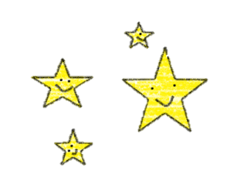
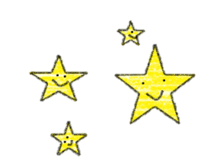
Information Session
Application

How to apply | Fill out the application form below and e-mail（nia5@niigata-ia.or.jp） or fax（025-249-8122） it in to the international association by following application deadline.
Application deadline | Joetsu | July 31（Mon）
 | Nagaoka | July 31（Mon）
 | Niigata | August 21（Mon）
Name
Nationality
Affiliation
(Town, college, etc.)
Contact | Address（〒 - ）
 | Telephone number
 | E-mail
Questions about the homestay or international exchange

※Homestay applications accepted until September 14th, 2017. We will distribute a profile sheet at the information session.

